FEDERAL STATE AUTONOMOUS EDUCATIONAL INSTITUTION OF HIGHER EDUCATION

ITMO UNIVERSITY

Report

on the practical Lab 2

“*India Population*”

Performed by

*Abizer Safdari*

*J41321c/J4134c*

St. Petersburg

2021

* Perform a ***sensitivity analysis*** for a demographic model with respect to a set of parameters: fertility rate, boys/girls ratio, «survival» rate for different age groups (not all can be taken). Model output: number of inhabitants for a given year. Test on the final forecast values ​​for 10, 20, 50, 100 years.
* Define ranges of model parameter values ​​from data for previous periods (1950-2000)
* Based on all ranges of parameter values, perform an ***uncertainty analysis*** in the form of a graph with confidence intervals of the results. The values ​​between the boundaries can be considered evenly distributed.

Input:

10 years

Sensitivity analysis

male sur sens:

[-0.02894122]

female sur sens:

[-0.01523998]

fertility sens:

[0.95348296]

newborn girl sens:

[0.]

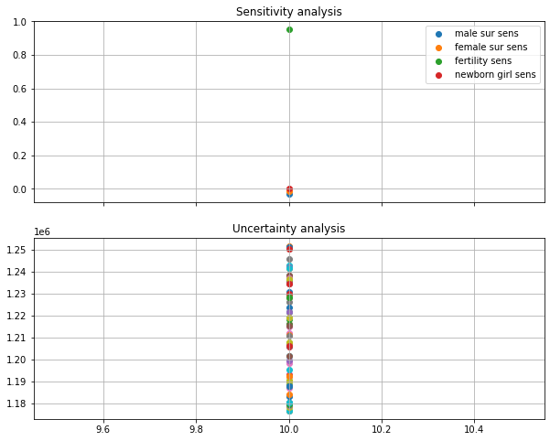

20

Sensitivity analysis

male sur sens:

[-0.02894122 -0.02711906]

female sur sens:

[-0.01523998 -0.00083247]

fertility sens:

[0.95348296 0.95780617]

newborn girl sens:

[0.00000000e+00 7.35266526e-05]

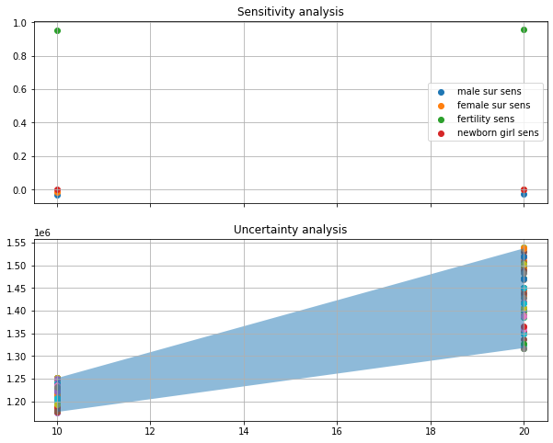

50

Sensitivity analysis

male sur sens:

[-0.02894122 -0.02711906 -0.02482788 -0.02186817 -0.01779253]

female sur sens:

[-0.01523998 -0.00083247 0.01488014 0.03303916 0.0440364 ]

fertility sens:

[0.95348296 0.95780617 0.96530963 0.97019208 0.97653525]

newborn girl sens:

[0.00000000e+00 7.35266526e-05 9.86547643e-05 7.69984850e-04

2.73237886e-03]

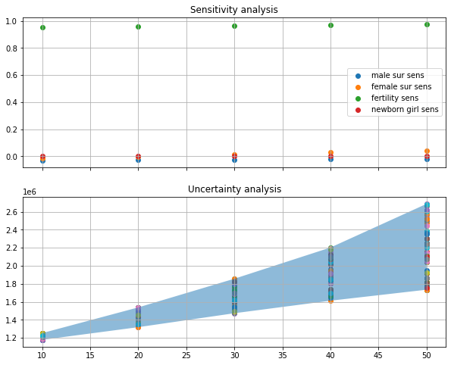

100

Sensitivity analysis

male sur sens:

[-0.02894122 -0.02711906 -0.02482788 -0.02186817 -0.01779253 -0.01489733

-0.01351881 -0.01181087 -0.01037976 -0.00932182]

female sur sens:

[-0.01523998 -0.00083247 0.01488014 0.03303916 0.0440364 0.04876273

0.05506315 0.05993939 0.06196577 0.06391729]

fertility sens:

[0.95348296 0.95780617 0.96530963 0.97019208 0.97653525 0.98193837

0.98372441 0.98387917 0.9846475 0.98627877]

newborn girl sens:

[0.00000000e+00 7.35266526e-05 9.86547643e-05 7.69984850e-04

2.73237886e-03 4.35957309e-03 5.35291257e-03 6.38617604e-03

7.41155003e-03 8.09552207e-03]

